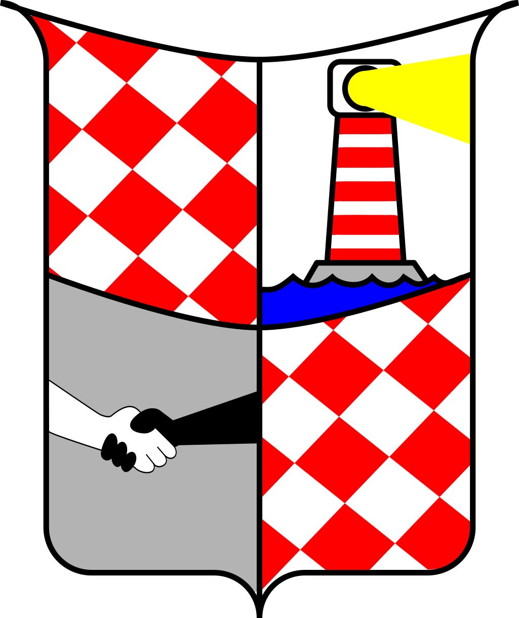

Copyright
© Peter Kastberger, 2017

License
Karlsburg as a setting can be freely distributed. This work is licensed under the Creative Commons Attribution-ShareAlike 3.0 Austria License. To view a copy of this license, visit http://creativecommons.org/licenses/by-sa/3.0/at/ or send a letter to Creative Commons, PO Box 1866, Mountain View, CA 94042, USA.

You are free to:

Share — copy and redistribute the material in any medium or format.
Adapt — remix, transform, and build upon the material for any purpose, even commercially.

The licensor cannot revoke these freedoms as long as you follow the license terms.

Under the following terms:

Attribution — You must give appropriate credit, provide a link to the license, and indicate if changes were made. You may do so in any reasonable manner, but not in any way that suggests the licensor endorses you or your use.
ShareAlike — If you remix, transform, or build upon the material, you must distribute your contributions under the same license as the original.
No additional restrictions — You may not apply legal terms or technological measures that legally restrict others from doing anything the license permits.



The OneDice Role-playing Game is written by Peter Cakebread and Ken Walton. Please keep in mind, that the OneDice RPG is a commercial product. Visit their homepage to get more information and support these great folks by buying one (or more) of their games and books!

http://clockworkandchivalry.co.uk/

Credits

I’d like to thank the following persons and communities: foremost my family & friends for letting me do what I do and for the inspiration and motivation. The OneDice RPG community on Google+, Regelleichte Rollenspiele und Storygames on Google+, the folks on reddit.com/r/mapmaking, reddit.com/r/worldbuilding and tanelorn.net. The folks behind the OneDice RPG rules.

I used some programs and fonts for this. Therefore I’d like to thank: the LibreOffice developers, the Inkscape developers, the MyPaint developers, the Krita developers, the GIMP developers. Lato font family by Lukasz Dziedzic, OpenComic font by Arthur Reeder with extra contributions by Gustav Hartvigsson. Cabin Sketch font by Pablo Impallari and Igino Marini.

And last but not least I’d like to say thank you to Jon Salway for proofreading. Thank you Jon!
Table of Contents
Introduction 1
Rules 2
Abilities 2
Optional Ability 2
Skills 2
Motivation and Trouble 5
Stunt points 5
The mechanics of motivation, trouble and stunt points 5
The city and it’s surroundings 7
Places one should know 7
Tourist information 7
B1 – Transmitting station 7
C1-D1 – Camp Opaque 7
E1-F1 – Karlsburg Airport 7
A2 – Hermitage 7
C2 – St. Michael’s School 7
E2 – Shopping Mall 7
E2 – Soccer Stadium “Chris Cornerkick” 7
F2 – Electricity Plant 8
A3 – Greystone Castle 8
A3-B3-B4 – Leacalan Forest 8
B2-C2 – Spring Green Park 8
B2-C2 – Water Tower 8
C3 – Renata’s Beauty Palace 8
C3-D3 – Sunny Sands Beach 8
D3 – Transmitting Station 8
D3-D4 – Scramblewoods 8
E3-F3 – Industrial Area 8
F3 – Dumpsite 8
A4 – Coldwater Cove 8
B4 – Transmitting Station 9
C4 – Small Harbour 9
C4 – Fritz Fisher’s Inn 9
C4 – Observation Point Arnoldstone 9
D4 – Amusement Park 9
D4 – Cabin in the Woods 9
E4-F4 – Harbour 9
B5 – Neptune’s Tables 9
D5 – Bluffy Boulders 9
E5 – Lighthouse Big Gerard 9
Involved parties, non player characters and villains 10
Parties 10
Family van Butterbrut 10
Wonderwuzzies 10
Terrarists 10
The Cornpirates 10
Non-player-characters 11
Nathalie van Butterbrut 11
Baron Bertram van Butterbrut 12
Baroness Eleonor van Butterbrut 12
Linda Lee the Librarian 12
Prof. Dr. Dressing 13
Police Chief Conrad Correct 13
General Hilaria Hazelstick 13
Mayor Margarete Mayonaise 14
Villains 15
Dr. Mangold 15
Terfloba 15
Archconsul Dominikus Gorgonius 15
Don Luigi Mortadella 16
Bullying Bruno 16
Captain Cratercheek 17
Mooks and minions 18
Danderoots (Terrarists) 18
Killer-Tomatoes (Terrarists) 18
Banana-Watchdogs (Terrarists) 18
Pirates (CornPirates) 19
Mobsters (Linguini Clan) 19
Common Bullies 19
Plot hooks for game masters 20
When kismet kicks in 20
Water and weed 23
Elevator pitch 23
How do the players get this information? 23
Ideas, scenes and locations 23
What’s next? Some ideas for making it difficult for the players. 23
Consequences 24
Lights out now! 24
Elevator pitch 24
Ideas, scenes and locations 24
Beneath Greystone Castle 24
Elevator pitch 24
Ideas, scenes and locations 24
Random tables 25
Character sheet 28
Tourist Map 30

Introduction
Karlsburg is a small setting for the OneDice RPG system. Karlsburg is based on one of my daughter’s ideas. She wanted to have a setting where everything is possible. Together we created the villains and main NPCs. After I looked down at what we had written, I suddenly knew what kind of feeling ‘Karlsburg’ gave me: think of Duck Tales, Darkwing Duck, Phineas & Ferb, Chip’n Dale Rescue Rangers, TaleSpin or even Adventure Time. Just think of any innocent and child-appropriate world. Where nobody gets wounded badly or dies. You want it darker? Let it look like ‘Gravity Falls’. There are evil guys, of course. But they are like the “Beagle Boys”, “Magica De Spell” or “Heinz Doofenshmirtz”. You see: “Karlsburg” is designed to be played with children.

If you asked me what genre it is, I would say “pulp” or “supers” with a light flavour of fantasy. However it is up to you and your party to make Karlsburg what you want it to be.

My daughter and I would like to wish you a lot of fun in Karlsburg. Enjoy!

Rules
Karlsburg uses the OneDice RPG rules. You can use the Quickstarter rules or the Universal rules. However we’ve made some changes to these rules to fit our needs. As the rules-part is so small, you can adopt it to any other role playing system easily.

Abilities
Instead of the common 3+1 base abilities, Karlsburg uses 4+1:

- Strong,
- Clever,
- Quick,
- Charming
- (Magic/PSI)

Charming is new and used for social tasks and wherever Clever may not be the right ability. It also covers empathy and such. Younger players are encouraged to use cleverness and social skills for problem solving instead of just violence and fighting.

Optional Ability
Magic – if a character needs it, this could be Psi or some sort of superpower as well.

Players usually have 8 Points to spend on these attributes, however the GM may grant the players up to 10 points if more powerful or experienced characters are needed.

Skills
The set of skills for starting characters is fixed. Players may spend 10 points to complete this stairway:

3
2
1

1 skill with a value of 3
2 skills with a value of 2
3 skills with a value of 1

Due to the additional attribute, a refactored skill list is necessary:

Skill | Ability | Description
Disguise | Charming | Good at carrying off a disguise.
Negotiate | Charming | Good at talking their way out of trouble.
Psychology | Charming | Good at reading people’s emotions.
Teaching | Charming | Good at getting basic concepts over to others.
Trade | Charming | Good at spotting a bargain, selling and negotiating.
Entertainer | Charming | Good at entertaining others.
Art | Charming | Good at creating art.
Artillery | Clever | Good at firing artillery weapons.
Command | Clever | Good at giving orders.
Computers | Clever | Good at building, repairing and using computers
Craft | Clever | Good at making and repairing things.
Cryptology | Clever | Good at creating and breaking codes.
Dodgy | Clever | Good at dealing with criminals and being streetwise.
Engineering | Clever | Good at building, repairing and understanding engines.
Investigation | Clever | Good at looking for and analysing clues.
Language | Clever | Good at speaking a language (other than the character’s own). Each language is a separate skill.
Lore | Clever | Good at knowing stuff.
Medicine | Clever | Good at healing people. Only people with medicine or magic can restore Health.
Navigate | Clever | Good at reading maps and following them.
Pilot | Clever | Good at piloting an aircraft, sea craft or spaceship, etc.
Research | Clever | Good at researching a topic, using libraries, computer archives etc.
Science | Clever | Good at science.
Security | Clever | Good at creating or picking locks, arming or disarming traps, etc.
Shooting | Clever | Good at firing a gun.
Survival | Clever | Good at surviving in the wilderness.
Track | Clever | Good at finding and following tracks.
Acrobatics | Quick | Good at acrobatic moves.
Archery | Quick | Good with bows.
Climb | Quick | Good at climbing.
Drive | Quick | Good at driving an automobile, hovercar, horse and cart, etc.
Gambling | Quick | Good at gambling.
Perception | Quick | Good at noticing and hearing things.
Pickpocket | Quick | Good at picking pockets.
Sneaky | Quick | Good at creeping up on people or hiding from them.
Throw | Quick | Good at throwing weapons (such as axes, daggers, etc.).
Blades | Strong | Good at hand to hand fighting with a bladed weapon (sword, axe, laser-stick, etc.).
Bludgeon | Strong | Good at hand-to-hand fighting with a blunt weapon (hammer, club, cosh, etc.).
Bruiser | Strong | Good at unarmed fighting (punching, kicking, head butting, etc.).
Intimidate | Strong | Good at bullying others.
Swim | Strong | Good at swimming.

Motivation and Trouble
Every important character should have a motivation and a trouble. Both, motivation and trouble should be designed to act as advantages and disadvantages for the character, depending on the situation. The GM should try to trigger a character’s motivation and trouble whenever possible to make the story more exciting. Players gain a stunt point when they accept the trigger. Players can get advantages in a scene when they trigger motivations or troubles of NPCs, enemies, surroundings. This may seem strange, but is a concept borrowed from games like Fate and it works pretty well.

Stunt points
Players start each session with 4 stunt points. Points can be gained by getting their motivation or trouble triggered. This can be done by the GM, other players or even the player himself.

The mechanics of motivation, trouble and stunt points
The following example is meant to illustrate the concept of motivation and trouble and their interaction with stunt points.

Paul plays a character, called Strawberry Stan, who’s a private eye. Motivation: You’ll have my loyalty, if you can afford my service. Trouble: A glass of Hot Chocolate doesn’t harm anyone. Equipment: A suit, a trench coat and hat, a multi tool with lock picker, some money.
The combination of suit and trench coat gives a +1 armour against close combat attacks (knifes, bludgeons and such).

Strawberry Stan is a private eye who operates close with the Wonderwuzzies, though he would never call himself one of them. He has a lawful mind, but also wants go get paid for his work. Stan has a passion for Chocolate, particularly Hot Chocolate. When he sees or smells Hot Chocolate, he gets easily distracted.

Stan has to be the bodyguard for some important client in town. He’s disguised, but always near his client. The client wants to visit the shopping mall with his family, so they go there. As they walk along in front of the shops, it happens: someone drops a dazzling grenade, a troop of mercenaries in combat suits approaches the group. Four of the mercenaries try to get hold of the customer’s son, the others point weapons at the customer and his family. People in the mall scream and run.

Paul says: “I want to go and help. Can I get into the pit and beat them up?”

The GM answers: “You are outnumbered, alone and not armoured. How will you do this?”

Paul replies, that he is still disguised. The customer pays Stan well and he has the motivation, that one that pays him, deserves his loyalty. Paul wants to spend a stunt point and Stan could jump in and use his Bruiser skill.

According to the One Dice rules, he could – if successful – either ignore an opponent’s defence, or perform two attacks in the first round. The GM agrees. Paul will get +1 for being disguised and +1 for triggering his motivation when rolling on Strong 2 + Bruiser 2, when he spends the stunt point. He has 3 stunt points left now, but gains the benefits mentioned above.

After the thrilling situation at the mall – Strawberry Stan could defend the customer and his family, until the shopping mall’s security forces showed up – the kids want some distraction. So the family decides to visit the amusement park to fetch some candy floss. Stan is behind the family, always keeping an eye on them.

The GM narrates: “As you walk behind the family, all your senses are alert. You feel that this may not be over yet. And as you strive through the park with all its booths, lights and attractions, you smell it …”
The GM offers Stan a stunt point: “… someone offers Hot Chocolate. Will you concentrate on your job and keep following the family, or are you taking a break, because ‘a glass of Hot Chocolate doesn’t harm anyone’?”.

The GM wants to trigger Stans trouble. If the player accepts, he’ll get a stunt point and will have 4 points again. The situation may become more difficult for the players, more thrilling, more exciting. But isn’t this the reason for playing?

The city and it’s surroundings
Karlsburg is a beautiful city with its centre located at a river crossing. There it all started generations ago, when the first settlers decided to make it a wealthy place to live. Over the years the city has grown. It became an influence for the whole area, containing an agrarian economy and other industrial sectors. But Karlsburg also has other merits. Beautiful forests, hills and shores for those who love nature, but also cultural sights. But don’t let yourself be fooled. When there is light, there is also shadow. Dark figures, scallywags and others want a piece of this wealth too.

Thank goodness there is someone who is willing to stop these dark forces!

Places one should know
Every citizen knows the most important places, no matter if it’s a landmark, a public place, industry or something else. A city map with a list of the most important places is given away for free at the tourist information centre.

Go and get one!

Tourist information
Dear tourist! Please refer to the coordinates on the Karlsburg map to get the location for the following places.

B1 – Transmitting station
A huge technical construction for signal transmission.

C1-D1 – Camp Opaque
Camp Opaque is a local army base. Its commander is General Hazelstick.

E1-F1 – Karlsburg Airport
It started out as a small landing place for airships and balloons, but eventually became a big international airport.

A2 – Hermitage
A small monastery, run by a group of monks. The live on their own and hardly have contact to the town citizens. They are, however, a helping hand whenever someone is in need of support. Rumours have it, that they keep a secret. But no-one knows for sure. Is it a relic of a saint? Is it a secret library beneath the forest and hill?

C2 – St. Michael’s School
The biggest and best school in town. The building is known for its architecture. The school’s chess team is well known!

E2 – Shopping Mall
Every city needs a place where you can get the goods you need. Food, fashion, technical gadgets – you can get it in the shopping mall! Of course it’s also a place to hang out, go for lunch or meet with your friends!

E2 – Soccer Stadium “Chris Cornerkick”
Karlsburg United is the local soccer club! Every citizen is a fan! The stadium is used for other events as well, like concerts.

F2 – Electricity Plant
The electricity plant is located next to the river where it gets the energy from to power the turbines. Karlsburg has 100% ecological power!

A3 – Greystone Castle
Castle Greystone was built in medieval times. Back then it was connected to a manor and self-supporting. Nowadays only a small part is left habitable, the rest is a ruin. Rumours have it, that the castle was built upon an ancient dungeon.

A3-B3-B4 – Leacalan Forest
Leacalan forest is located on a small mountain in the south-west of Karlsburg. The forest is beautiful and everyone is welcome for hiking or biking!

B2-C2 – Spring Green Park
People like to spend their free time in the park. And Spring Green park is the most beautiful one you can imagine. People gather there for barbecue, sports or just to walk the dog or read a book!

B2-C2 – Water Tower
The water tower is kind of a backup system for Karlsburg. It also brings the drinking water to the areas in town, where the rivers don’t flow.

C3 – Renata’s Beauty Palace
If you want to relax, then Renata’s Beauty Palace is the place to be. Renata offers various health & care services. Hair-dressing, nails, massage.

C3-D3 – Sunny Sands Beach
The citizens enjoy the summer days at the beach. Sunny Sands Beach is located between Leacalan Forest and Scramblewoods.

D3 – Transmitting Station
A huge technical construction for signal transmission.

D3-D4 – Scramblewoods
A deep and dark forest. Only the hunters and woodsmen go there. Normal people tend to avoid this strange place.

E3-F3 – Industrial Area
A lot of Karlsburg’s wealth depends on this healthy industrial sector. Goods are designed, produced, processed and traded there.

F3 – Dumpsite
A town with such a number of residents has to cope with it’s waste. The local dumpsite is the place where all the waste goes.

A4 – Coldwater Cove
The coldwater cove always has been a smugglers’ meeting point and hideout. There is a small settlement but the residents are solitary people. Who knows – maybe it’s still a meeting point for smugglers? Though it’s a small cove, the water is dark, cold and deep. When the weather is bad, it becomes dangerous there, as the waves grind the ships on the stones.

B4 – Transmitting Station
A huge technical construction for signal transmission.

C4 – Small Harbour
The small harbour is for the citizens’ sailing boats. There is no industrial business there.

C4 – Fritz Fisher’s Inn
Fisher Fritz is a famous fisherman and cook. He gets up early to catch the best fish and brings it to the table in his famous restaurant.

C4 – Observation Point Arnoldstone
People go there by bike, they walk there, the go there by car. The observation point is the place to be, when you want to take a photo or just enjoy the beauty of the whole area.

D4 – Amusement Park
The city’s amusement park. It has everything you can imagine to have an exciting day! An observation wheel, a roller coaster, popcorn, a hall of mirrors and much, much more.

D4 – Cabin in the Woods
An old wooden house deep in the woods. Hunters shun it because it is so mysterious. Though no one lives there, people say that sometimes there is a shining light in the house.

E4-F4 – Harbour
The harbour is busy 24/7. Goods from all over the world are processed there. Sometimes these goods stay in the huge cargo containers, sometimes they get into one of the huge warehouses. Some goods are brought to the industrial area for further processing. The harbour with is countless number of companies gives employment to lots of people in Karlsburg.

B5 – Neptune’s Tables
Neptune’s tables are a famous observation point. The stones have a unique structure and old myths tell stories about how these flat ‘tables’ came to look that way.

D5 – Bluffy Boulders
These boulders are rocks soaring out of the water like the top of an iceberg. Lots of innocent sailors have seen their ships sinking there. Be cautious when you sail near them! People tell legends about creatures living at the bottom of these rocks, waiting for ships to capture.

E5 – Lighthouse Big Gerard
The lighthouse is an important part of the infrastructure in Karlsburg. Without it, ships would end up sunk as victims of the bluffy boulders.

Involved parties, non player characters and villains

Parties

Family van Butterbrut
The family van Butterbrut owns several dairies and eventually became part of the nobility. They are the “milk-aristocracy” in Karlsburg. They sell it to the industry and local stores. The family is held in high esteem. Baron Bertram van Butterbrut and Lady Eleonor van Butterbrut are officially retired, but Baron Butterbrut still has a lot of influence. Lady Butterbrut is always busy with her charity events. The dairies are managed by their daughter, Nathalie van Butterbrut.

Wonderwuzzies
A group of fearless heroes and adventurers. They’re always willing to do the right thing and to serve and protect the helpless. They are lead by Nathalie van Butterbrut. Their technical support comes from Prof. Dr. Dressing, who is inventing crazy new items all the time. The player characters are actually part of the Wonderwuzzies.

Terrarists
A gang of evil beings, crazy plants and mutant vegetables. They want to destroy the van Butterbruts and their dairies. In general they are evil-doers and always up for undermining society and causing harm to the brave citizens of Karlsburg.

The Cornpirates
The Cornpirates are a constant threat to Karlsburg’s port. They waylay merchant ships that come to or leave Karlsburg. No one knows where their lair is.

Non-player-characters

Nathalie van Butterbrut
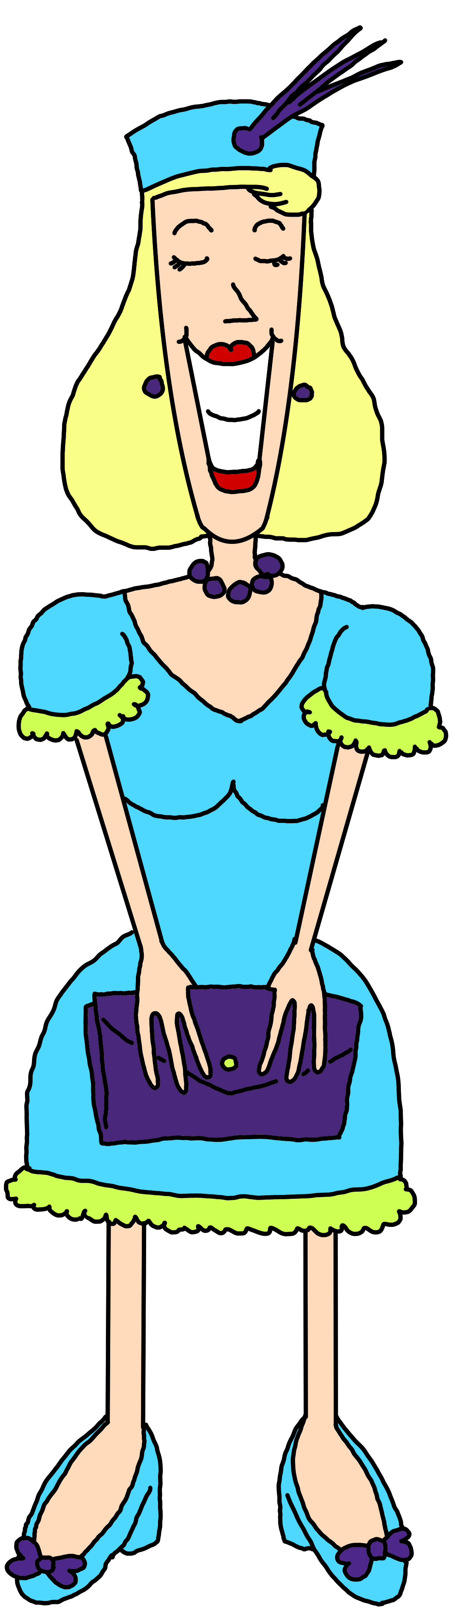
Nathalie is a nice young lady. Friendly, fair and good looking. CEO of “Butterbrut KG”, the leading company when it comes to milk-products. What people do not know is, that she’s also leading a secret organization of justice fighters. Usually the players are part of these ‘justice fighters’, called the “Wonderwuzzies”.
Motivation: I lead the Wonderwuzzies. because it is the right thing to do.
Trouble: I don't see the problem.

Baron Bertram van Butterbrut
Bertram is the family clan’s head. He’s a very successful business man with wide ranging influences. He’s a calm and quiet man who knows his duties. He wants to change the world for the better and appreciates the dangers that his enemies present.
Motivation: For mankind and humanity!
Trouble: The higher goal is more important than a single one’s destiny.

Baroness Eleonor van Butterbrut
Baroness Eleonor is a born noble, just like her husband. As Baron Butterbrut takes care of the business, Lady Butterbrut has enough time for her charity events. That’s her life – organizing events and giving the money raised to those who need it the most.
Motivation: Noblesse oblige.
Trouble: No one ever is evil out of fun.

Linda Lee the Librarian
She’s the town’s memory. Linda Lee knows everything about the town and its citizens. Chitchat or gossip is her favourite kind of information. She’s very nosy.
Motivation: Oh really? Tell me more about it!
Trouble: Have you already heard about this?

Prof. Dr. Dressing
He’s the genius in our setting. Officially working for the Butterbrut-laboratories to make better butter and cheese, he’s the inventor of gadgets for the “Wonderwuzzies”.
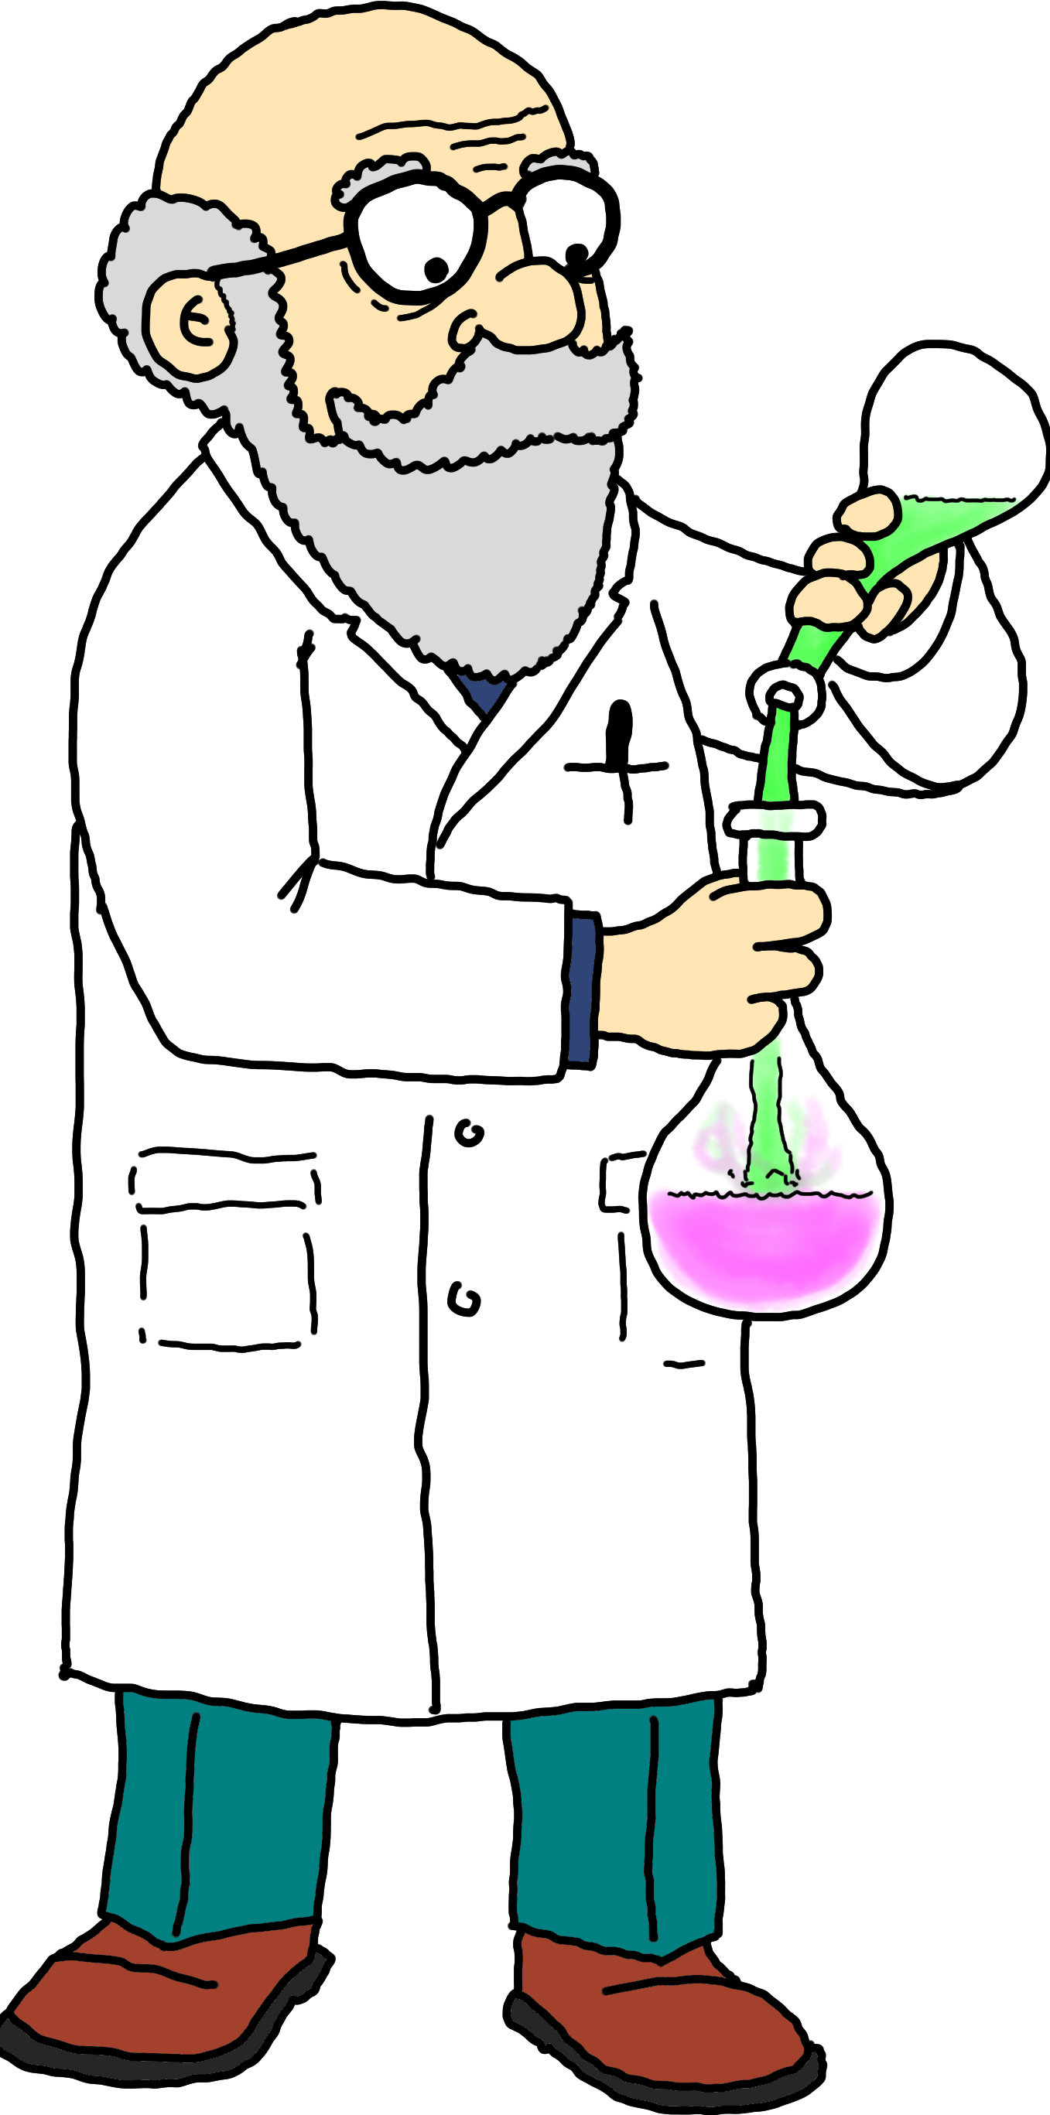
Motivation: We have to find out!
Trouble: I seek courage behind my microscope.

Police Chief Conrad Correct
As a child Conrad played cops and robbers. He always wanted to be a policeman, to serve and protect. He loves teaching the traffic laws to the children in school and enjoys a walk with his dog Jamie. As a policeman he’s always a little worried. He likes to be prepared for everything, but that’s impossible.
Motivation: To serve and protect.
Trouble: He has to be prepared!

General Hilaria Hazelstick
General Hilaria Hazelstick is responsible for Camp Opaque. She is known for her coldness and strict discipline. She's been in the Army for years now and has seen all kinds of conflicts. Hilaria acts in a strategic manner. Camp Opaque may have a hidden agenda, but no one knows as it's operating self-contained outside of town.
Motivation: Government is my father
and my mother.
Trouble: I just can't feel anything.


Mayor Margarete Mayonaise
Mayor Mayonaise is the leader of the town. She’s always busy, one can call her at any time – she will pick up the phone to help. She’s always up to make the city a better place. Whenever there is a feast at a school or kinder garden – Margarete is there. Her only pastime is walking dogs and petting cats at the local animal shelter.
Motivation: The show must go on!
Trouble: You have to understand that it’s for all of us!

Villains
This is just an overview of villains and evil-doers which we were able to come up with. Go ahead and create your own, if you see fit!

Dr. Mangold
He’s the evil genius, the dark twin to Prof. Dr. Dressing. Both have been rivals since kinder garden. Dr. Mangold is supporting other evil groups in Karlsburg, but also working on his own.
Motivation: I can do what he does, but better.
Trouble: I deserve respect for my work!

Terfloba
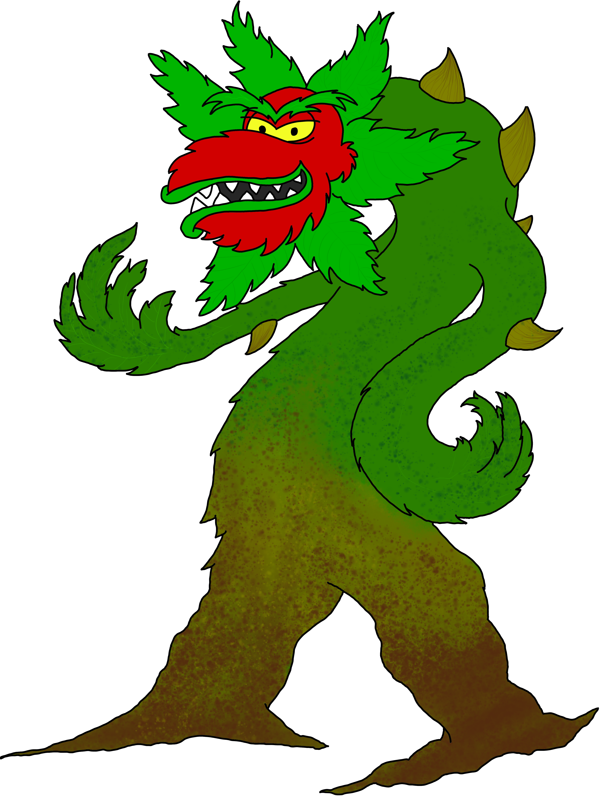
A giant mutant carnivorous plant and leader of the “Terrarists”. Terfloba is the result of an unsuccessful experiment of Dr. Mangold, the worst enemy of Prof. Dr. Dressing. Terfloba is intelligent, violent and eager to smash everything. He hates the Wonderwuzzies. and wants to destroy them. He has a hidden laboratory where he grows and cultivates his minions.
Motivation: Destroy all humans.
Trouble: I was never meant to be.

Archconsul Dominikus Gorgonius
Dominikus Gorgonius once was a fellow student to Baron Bertram van Butterbrut. They have been rivals ever since. Dominikus is obsessed by having more success and triumph than Bertram. Dominikus is collecting all kinds of rare pieces of art from all over the world. He's been travelling all over the world and sees himself as a colonial emperor.
Motivation: It all shall be mine.
Trouble: What does he have that I don't?

Don Luigi Mortadella
Underworld boss. Don Luigi is the godfather of the “Linguini Clan”. Ever since he was a young child he has been involved in the crime scene. He started out as an errand-boy but eventually became the boss of bosses.
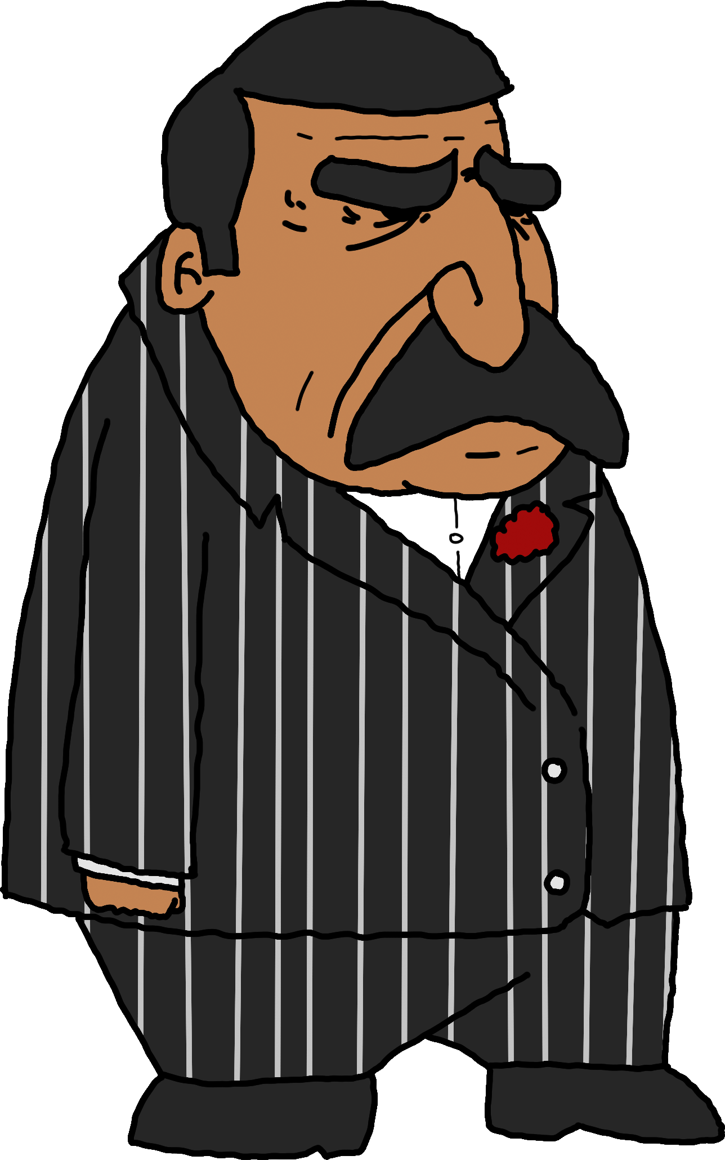
Motivation: We'll contrive ways and means to get what we want.
Trouble: I trust no one.

Bullying Bruno
Bruno is well known by the police. A bully, a hooligan, a scallywag. He’s always looking to pick on someone who’s smaller than him. And Bruno is as strong as an ox! He’s the kind of person you do not want to meet when walking home at night. Most of the time he’s in the company with his gang members.
Motivation: C’mon, gimme that – I wanna have it.
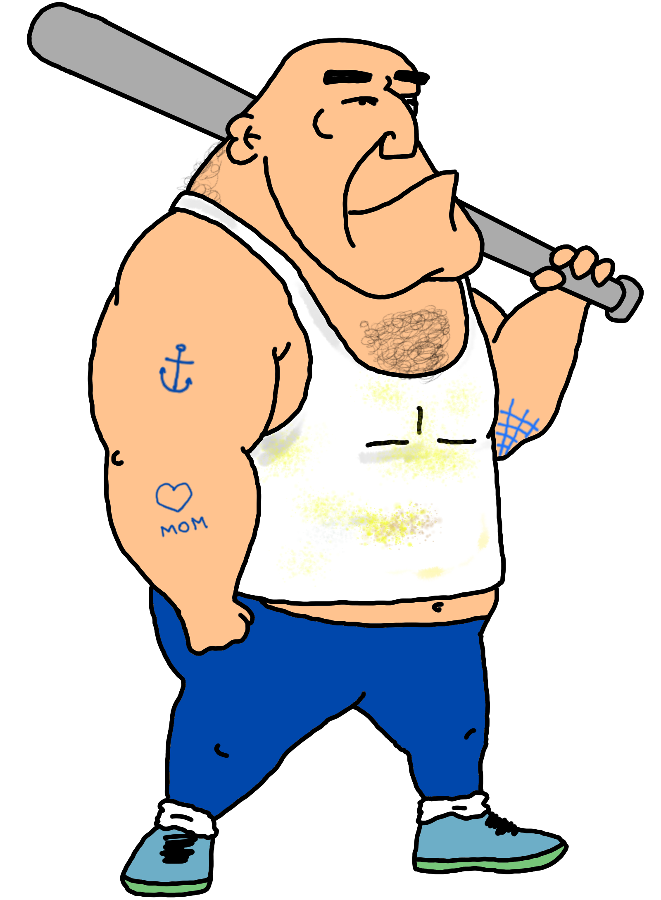
Trouble: One, two, three – ahhh – many?

Captain Cratercheek
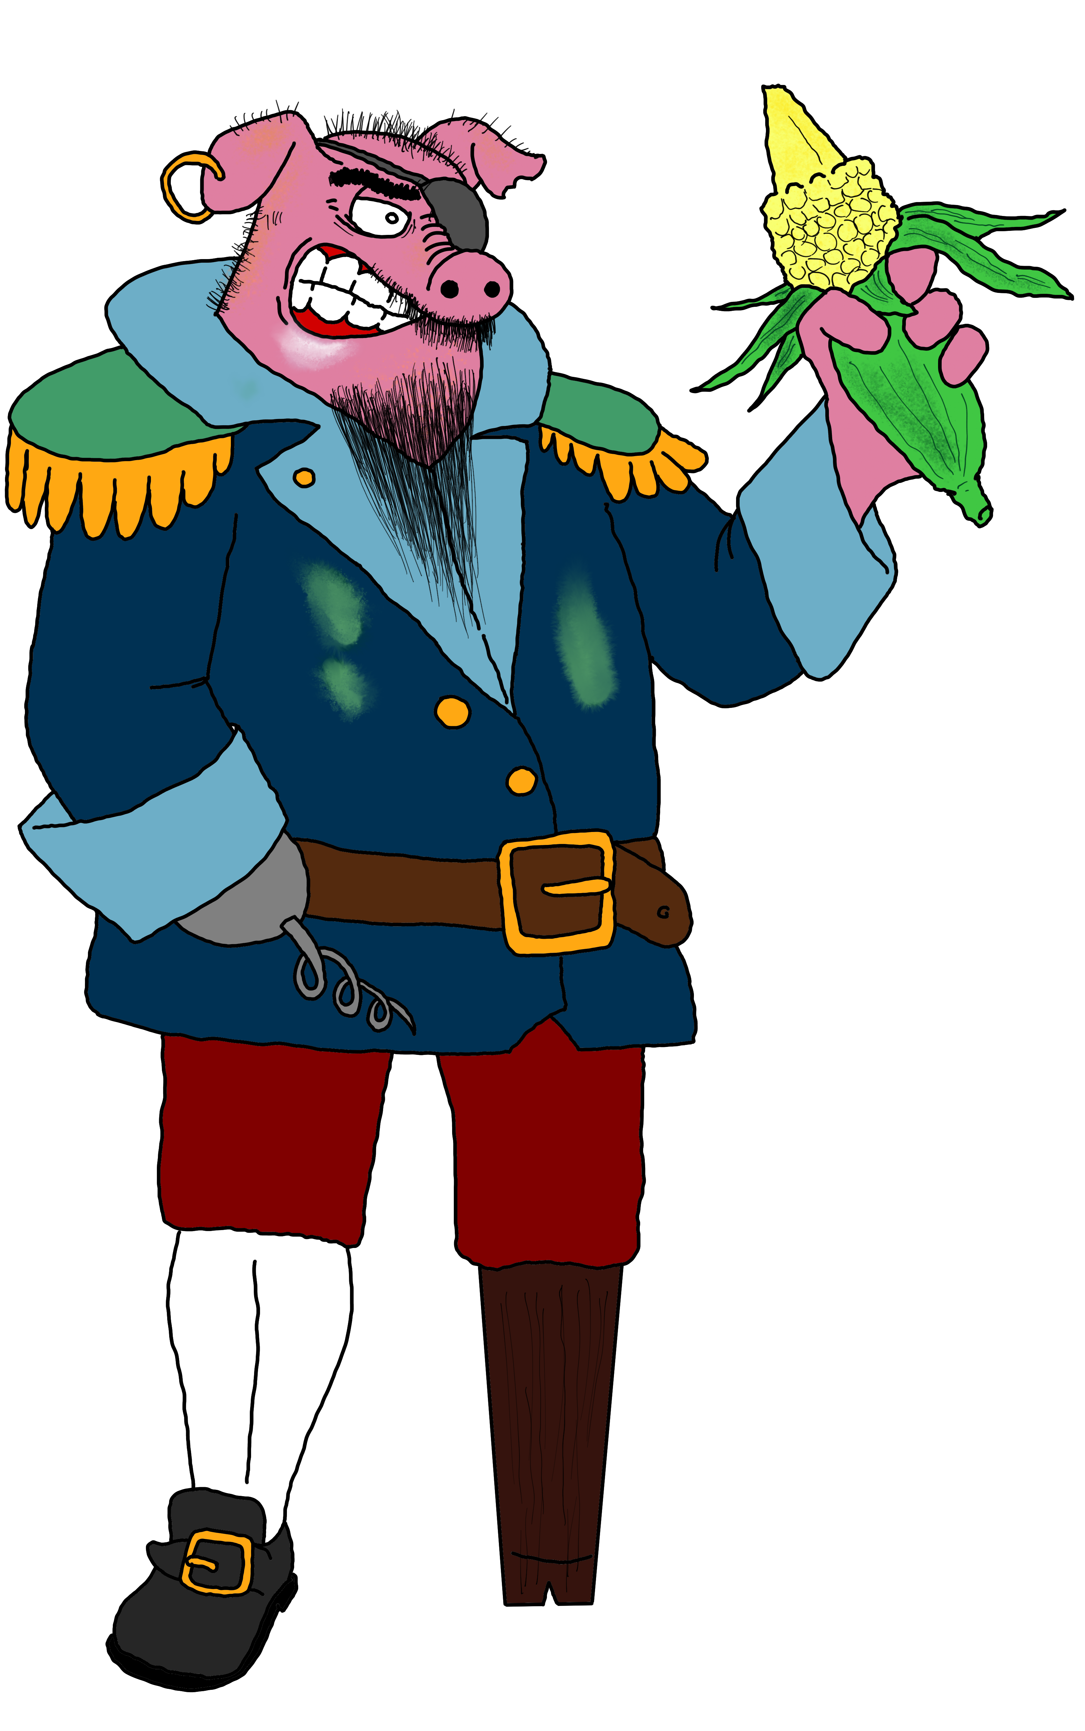
Cratercheek is a pirate-boar and the leader of the “Cornpirates”. His passion with corn is so huge, that he decided to become a pirate as a child to trap all the merchant ships that come to Karlsburg's port.
Motivation: For the crown of corn I was born.
Trouble: There's nothing of interest besides corn.

Mooks and minions

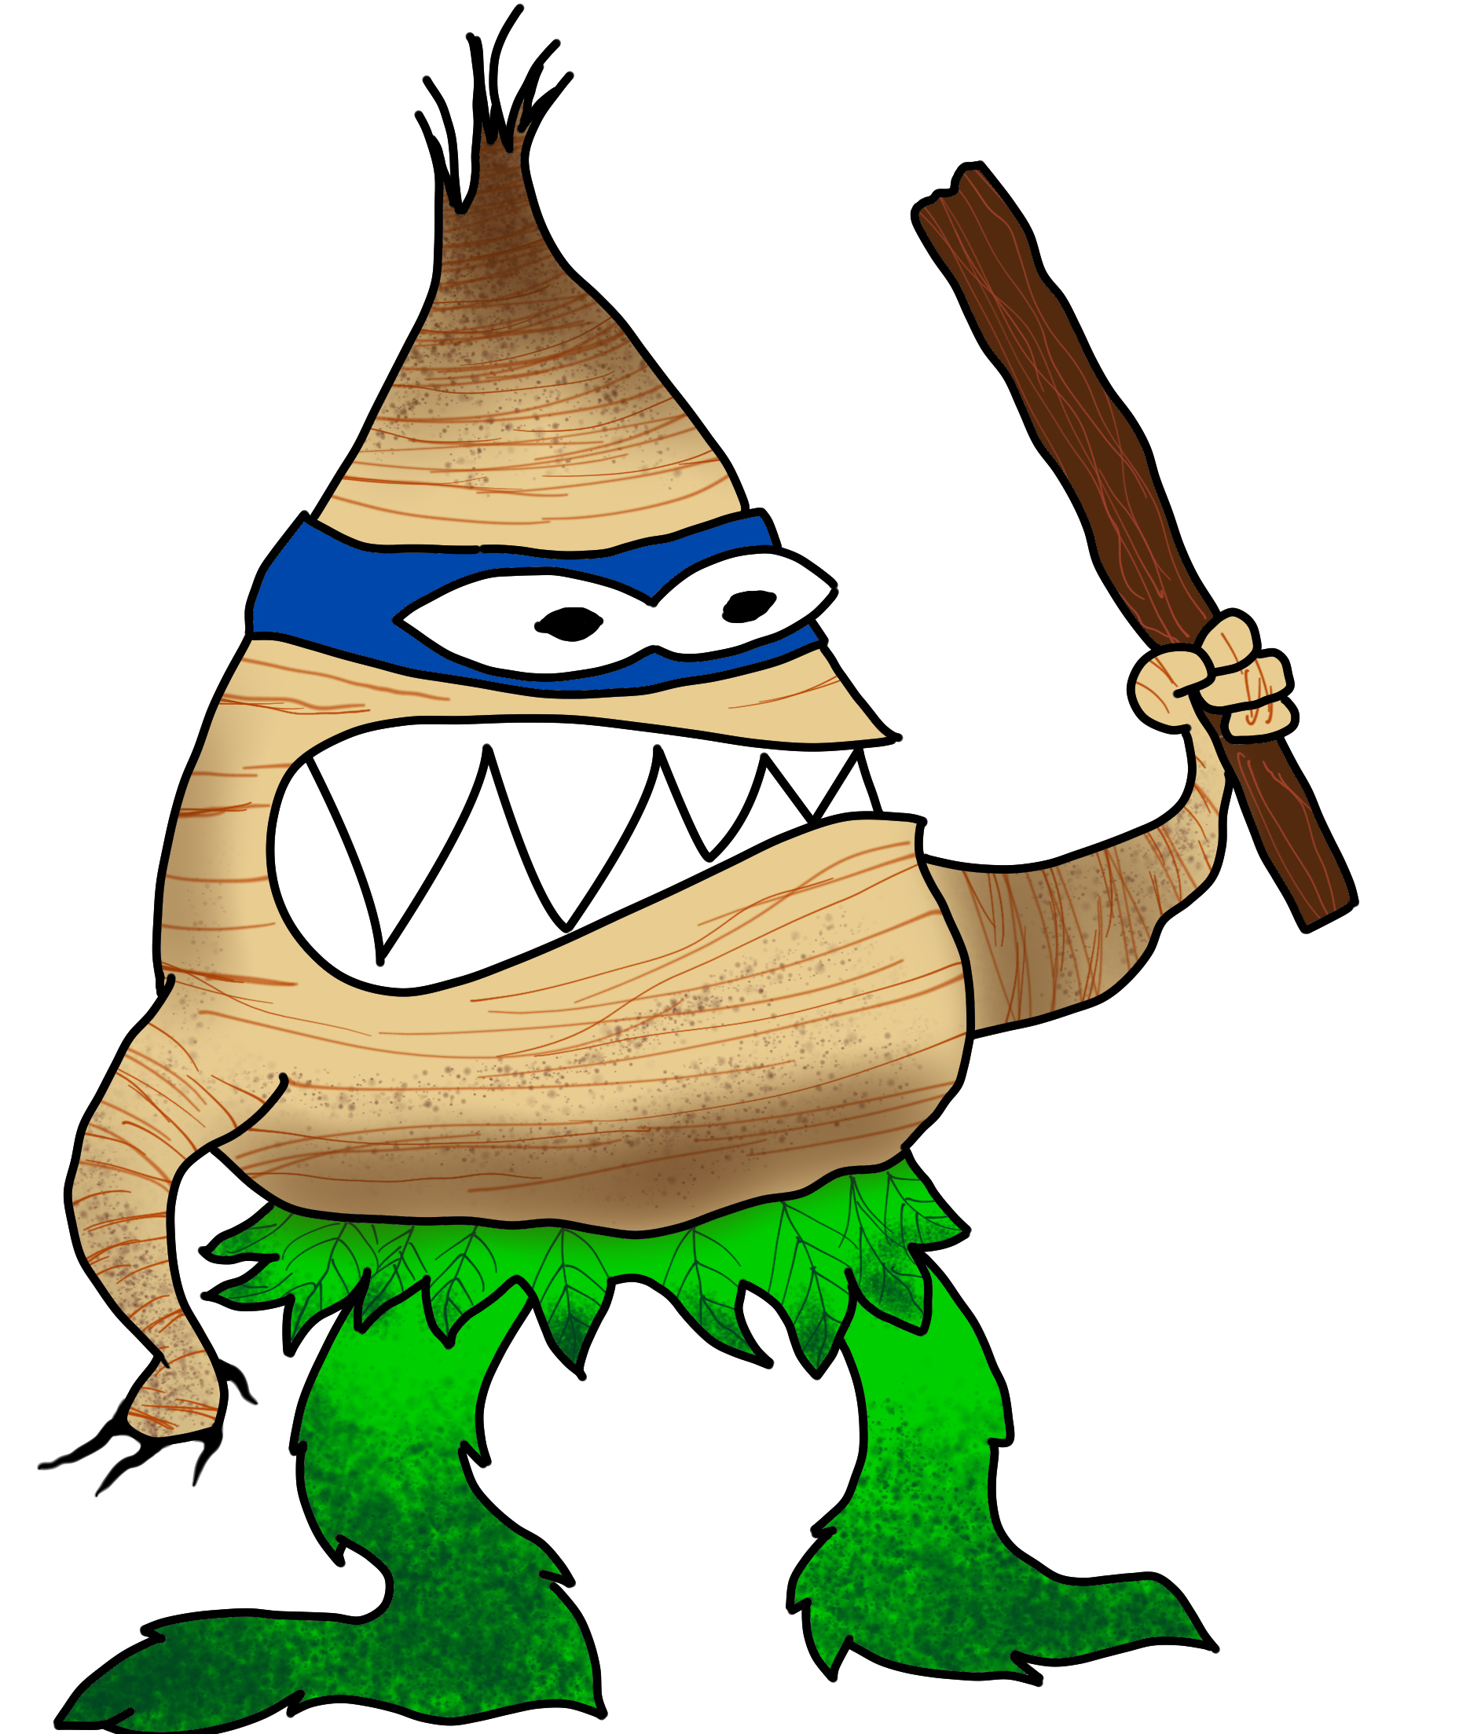
Danderoots (Terrarists)
Angry little plants. They use hands, teeth or even a fellow root to hurt an opponent. They tend to follow their enemies wherever they go. They're quite good at running and climbing, they even build ladders (actually they just pile up) to get up walls quickly. They float on the surface of water, they are miserable at swimming.

Stats suggestion: [] out of fight. Combat: 2, everything else 2, move 30, defence 6.

Killer-Tomatoes (Terrarists)
Semi-intelligent rolling tomatoes. They follow Terfloba's command and don't care if they end up as spaghetti-sauce. A single Killer-Tomato is dumb and one can outsmart it easily. But a mob can be a real danger to any hero!
Stats suggestion: [ ] out of fight. Combat: 3, everything else 2, move 20, defence 9.

Banana-Watchdogs (Terrarists)
A giant banana that has bloodhound-DNA. They bark very loudly. Whenever Terfloba is in town for doing evil, a group of Banana-Watchdogs is with him as his guards.
Stats suggestion: [ ] out of fight. Combat: 2, everything else 2, move 20, defence 3.


Pirates (CornPirates)
The Cornpirates are henchmen to Captain Cratercheek. Always watching out for corn and doing evil, they must not be underestimated. It’s not easy to become a member of Captain Cratercheek’s crew. So be careful when you encounter a Cornpirate. They’re tough opponents!
Stats suggestion: [ ] out of fight. Combat: 3, everything else 3, move 10, defence 9.

Mobsters (Linguini Clan)
They are usually members of the Linguini Clan, or at least very close. Don Luigi never wants to get his hands dirty. For the dirty work he has all the aspiring men and women who want to climb up the ladder of ranks within the clan. Most of the mobsters are very ruthless and obey to whatever their boss says.
Stats suggestion: [ ] out of fight. Combat: 2, everything else 2, move 30, defence 3.

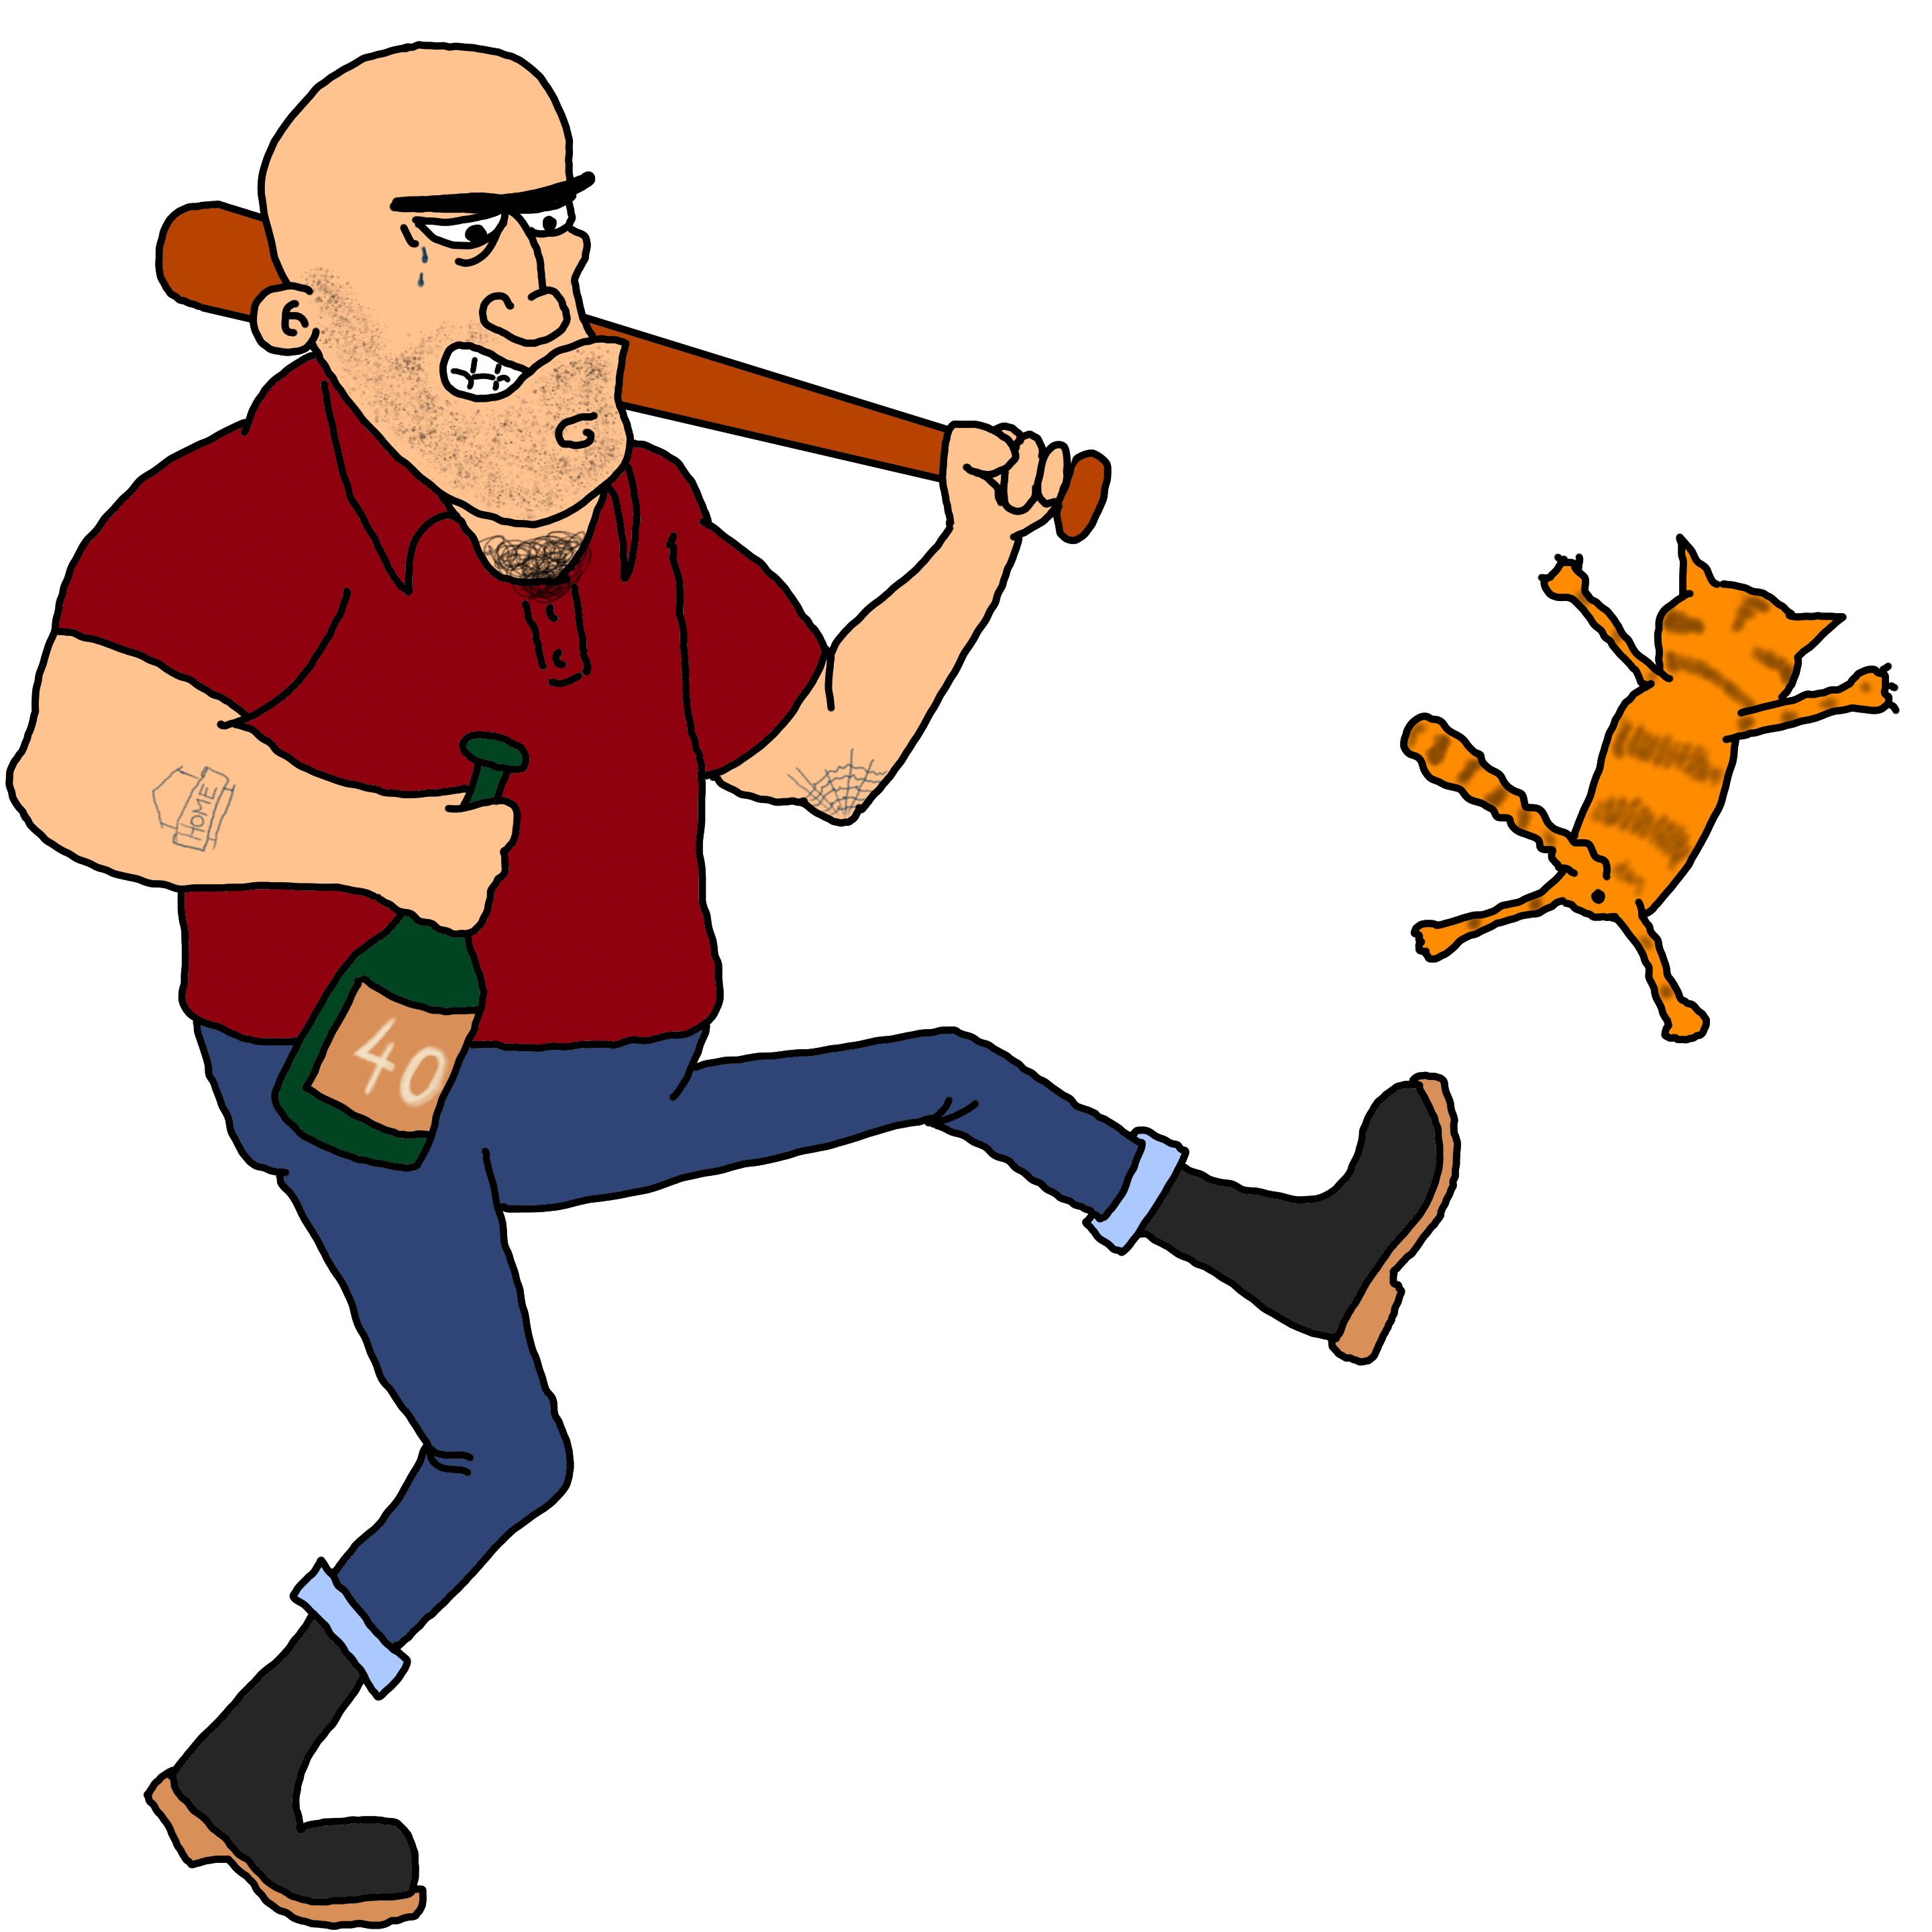
Common Bullies
There are several groups and gangs in Karlsburg that lend a hand to all the evil villains whenever they call out for support. They don’t belong to particular groups and may appear in every inopportune situation, as long as they get some sort of reward.
Stats suggestion: [ ] out of fight. Combat: 2, everything else 2, move 30, defence 3.

Plot hooks for game masters
Here are just some ideas that you can use as an adventure. Feel free to change the ideas, cut them down or extend them as you see fit. Some ideas have random tables. Choose from these tables or roll 1D6 for a random item. Or use your own ideas!

When kismet kicks in
This is an introductory adventure for people totally new to role-playing-games, especially children. Gamemasters may read it to get comfy with the rules.
A special note for the game master:
In this introductory adventure the tests are mostly laid out on a string. The story is highly railroaded and the players do not have any options besides the intended ones. The only reason for this approach is to learn the rules and basic mechanics. For further play, please avoid such. This would be boring and frustrating for the players. A story must not get stuck, when a test fails. Fail forward is the motto!
To become a member for the Wonderwuzzies., the new heroes have to complete a training module. The adventure starts in a white room. The room is coated with paddings, but there are no windows, no decorations or such. Just padding and a linoleum floor. In one corner beneath the ceiling is a camera, in the opposite corner is a speaker.
A synthetic voice comes from the speaker: “Hello, emerging heroes! I’m happy to welcome you at our training course. Here you can test and play with all your abilities and skills. You’ll get confronted with different challenges. Be smart and use your skills, your equipment and your brain! Use the environment. Violence and fighting should be avoided and remain the very last option. Don’t be afraid – this course is a simulation. You’re quite save. All the best to you!”
Now the heroes are left alone in the room. Walls, floor, the camera, the speaker. LED-lights in the ceiling. One of the walls contains a hidden door. The heroes should be able to find it by examining the walls with their hands without rolling dice. However they should be encouraged to ask questions about their environment. When the door is found, the voice goes on again: “Well done! You’ve already learned the most important thing: look around, ask questions and think about the things you’ve heard. The Game Master will always tell you the truth about the situation and the surroundings. He is not your enemy, he’s your eyes and ears! The more you act, ask, look and feel, the more the Game Master will tell you about your the world you’re in. So don’t be chickenhearted – be heroes! Now it’s time to discover your abilities. They are noted on identity card. You’ve found the hidden door, but how does it open? The door has no handle, no hinge. Therefore I recommend: push against it. To be successful, you’ll need to make a skill check against ‘STRONG’. The door’s heavy, so the check is CHALLENGING (6).”
Now the players can make the skill check. If a player has an appropriate skill, he can use it according to the One Dice rules. The players can even try to open the door as a team: one player does a regular skill check, the others make a check as well but support the first player. Each successful supporting player gives a +1 to the first player and refrains from a further single action. Team-building is wonderful!
On a success, the door swings open into a small hallway and the synthetic voice says: “Great. Remember: your ability STRONG is used for good for everything where you need strength and power like pushing, pulling, lifting, thumping enemies with fists or a hand weapon, etc.!”
The hallway is small, white, spares and follows a curve to the right. There’s really nothing to see or interact with for the party. The door behind them automatically closes, so they have to go forward and follow the path.
After a few meters, behind the curve, the heroes get into a hall. The hall is divided by a huge water pool. The opposite edge is higher then the edge their are standing at. Both edges are connected by a cargo net. The net is about two feet wide.
“Time to have a go at another ability! QUICK is used for climbing, going first in a fight, firing a bow, sneaking and such. Whenever dexterity is key, use this ability! All you have to do, is climbing to the other side on that cargo net. That's a mildly challenging (3) task. You already feel like one of those ninja warriors on TV, don’t you?”
The heroes are supposed to roll for QUICK each, plus an appropriate skill, if available. If a hero fails the test, he just falls down into the water without any harm. The hero just has to swim back to the lower edge and climb out to try again.
When the heroes are all on the other side, the are faced with a hallway again. Small, sparse and slightly with a curve to the right again. After a certain distance, the hallway ends in front of a heavy door. The door has a normal handle – so the party may walk through. They’ll get into a small room and as soon as the door closes behind them, a strange mechanic shows up on the opposite side. The mechanic is a device with gears and such.
“Now let’s test your intelligence. Try to reveal the device’s secret to to go on.”, the synthetic voice tells the party.
The device, or better its complexity should be adopted to the players. Therefore there’s no detailed description here. Maybe it’s enough for the heroes to make a test for intelligence, maybe you want to create some sort of riddle for the players, before they are allowed to make a skill test. Make a distinction between the players and their skills and the characters and their skills. On a successful test against CHALLENGING (6) the mechanic’s function can be revealed and the exit opens. Again, teamwork (+1), is an option. Every failed test lets the ceiling drop for a few centimetres. If the ceiling becomes a real danger and the characters might get hurt, the concept of stunt points for automatic skill test success should be introduced (if one can trigger his motivation or trouble).
As soon as the mysterious mechanical lock is opened, the ceiling stops dropping and another hidden door opens. The heroes now see – surprise, surprise – a white hallway. As they follow the hallway again, they come to another door. This time, the computer voice talks before they walk through: “Now it’s time to test your last ability. Good look!”
The following scene allows the players to interact and role play with non-player characters. Social skills, trading, empathy but also negotiating, psychology and wire-pulling should be introduced. However, there should be some sort of incident that leads to a confrontation or fight later on.
As the characters walk through the door, they see some sort of market in a huge hall. Like a bazaar. It’s totally crowded. You can hear voices and sounds, smell spices and see a wild mixture of different people. Small, big, adults, aged, children. Most of them are busy, some are just sitting around. Merchants praise their goods, possible customers eyeball the products.
Of course, the door behind the heroes closes again and they can’t see any door out of this hall at a first glance. It seems obvious, that they might make their way to the other side. Maybe there is an exit. That depends on how the story evolves. The heroes might talk to people passing by and to merchants. From now on you have to really game master. The railroading pretty much ends here as you can’t foresee what the players will do. Here are some ideas:
- Maybe they want to ask their way through – let the NPCs react randomly. You can use the random tables chapter from page 25 for this. Most NPCs might be neutral to the characters, some are really friendly and others are … well, let’s say: grumpy. If the players overstep the mark, the situation might escalate.
- Maybe someone is begging for help? Don Lugi’s minions are at the market as well and try to pinch money from the merchants.
- Maybe one of the merchants call the players thieves?
- The characters could also try to by a map or simply buy the information to get out. But do they meet an honest person?
- Maybe some of the Cornpirates try to steal a delivery of corn from one of the merchants? The players are asked for help.
- Maybe some pickpocket fetches something from one of the characters and they chase him. As they rush through the market, they damage some of the stalls and the merchants get angry.
Whatever you do: be creative and be fair to the players. Remember – it’s an introduction. Have fun!

Water and weed

Elevator pitch
Terfloba wants to poison the town’s drinking water with weedkiller.

How do the players get this information?
1 | A computer monitoring system recognized a quite huge amount of weedkiller being sold to an anonymous person.
2 | A turncoat gave the information to the police and hopes to get out scot-free.
3 | Some worker saw a huge container with weedkiller being discharged at the port and some shady characters.
4 | A local producer of chemicals was raided. All the necessary ingredients for making weedkiller were taken. Prof. Dr. Dressing can tell, that it must be weedkiller, if the players need a hint.
5 | The weedkiller was stolen from the farmers in Farside Acres.
6 | Some NPC informs the players. The source of information is unknown and/or not important. You jump right into the adventure.

Ideas, scenes and locations
The players could try to disturb the handover of the weedkiller from the buyer to Terfloba.
If Terfloba already has the weedkiller, the players may try to find out where he wants to place his harmful present.
1 | River
2 | Wastewater treatment plant
3 | Water tower(s)
4 | Cistern(s)
5 | On the crop fields to poison the food
6 | Soccer stadium

What’s next? Some ideas for making it difficult for the players.
- The players could be forced rush to all the known cisterns in town within a given time to crash Terfloba’s poisoning party.
- Maybe Terfloba has not yet placed the weedkiller. The players could try to install some filters, special devices into crucial infrastructure without having Terfloba recognizing it.
- Terfloba was successful. The weedkiller is in the water. The players have to quickly find the ingredients for an antidote. They’ll get a list from Prof. Dr. Dressing.
- The players find out, when and where Terfloba plans to poison the water. It comes to a showdown.

Consequences
What happens, if the players don’t manage to stop Terfloba injecting the weedkiller into the drinking water supply? Does it have immediate consequences, or do the players have to accept their defeat and the current results yield a new adventure? Here are some thoughts:
- Players have to find an antidote and supply it to the water system (already covered above) or start production of some medication.
- Help local Red Cross and hospitals with emergency patients.
- Players have to work as a replacement for others in town.
- Maybe an upcoming festival can not take place, or is at least threatened. The citizens get ill and have to stay in bed for a few weeks.
- If Terfloba poisons the crop fields, the players would have to find a substitute for the town citizens to eat.

Lights out now!

Elevator pitch
Captain Cratercheek has planned to sabotage the lighthouse Big Gerard.

Ideas, scenes and locations
Without the lights, the ships can’t navigate to the harbour. They would have to stop and wait on the high seas or run into the danger of colliding with the bluffy boulders or other ships. While the ships wait at sea, Captain Cratercheek plans to raid them to get their goods – especially corn.

Beneath Greystone Castle

Elevator pitch
Dominikus Gorgonius wants to do a ritual beneath Greystone castle. The ritual will enable him to be the most powerful person the world has ever seen!

Ideas, scenes and locations
Gorgonius has paid some mooks to break into the museum and steal an ancient Egyptian talisman.
This adventure can be played as a classic dungeon crawl or as a detective story. The heroes could investigate the museum as a crime scene. Maybe Baron van Butterbrut has some old scroll, where the talisman is mentioned and so get a clue? Maybe Linda Lee the Librarian has a book about it? The book could contain some information about a medieval knight that once had the talisman but lost it. The knight later became a resident of castle Greystone.

Random tables
If you just can’t come up with an idea – no matter if it’s a player character, an NPC a place or plot – you can use the following tables to set something up quickly.
Your life is connected to a spot in or around town in some way.
Which is it?
1 | It’s a public place. Please roll on the “Public places table” for details.
2 | It’s a place in nature. Please roll the “Nature places table” for details.
3 | It’s a place of infrastructure. Please roll the “Infrastructure table” for details.
4 | It’s a mysterious place. Roll the “Mysterious places table” for details.
5 | It’s some other place. Roll the “Other places on the map table” for details.
6 | It’s a different location in Karlsburg. Roll the “Different location table”.

 | Public places
1 | Library Saint Wiborada
2 | Soccer & Athletics Stadium Chris Cornerkick
3 | Observation Point Arnoldstone
4 | Amusement park
5 | Spring Green Park
6 | Sunny Sands Beach

 | Nature places
1 | Coldwater cove
2 | Bluffy Boulders
3 | Sunny Sands beach
4 | Somewhere by river
5 | Scramblewood
6 | Farside Acres

 | Infrastructure
1 | Airport
2 | Harbour
3 | Electricity plant
4 | Water tower
5 | Dump site
6 | Industrial area

 | Mysterious places
1 | Cabin in the woods
2 | Neptun’s tables
3 | Transmitting station (re-roll: 1,2=1 – 3,4=2 – 5,6=3)
4 | Camp Opaque
5 | Castle Greystone
6 | Museum

 | Other places on the map
1 | Castle Greystone
2 | Transmitting station (re-roll: 1,2=1 – 3,4=2 – 5,6=3)
3 | Small harbour
4 | Sunny Sands beach
5 | Lighthouse Big Gerard
6 | Hermitage

 | Other possible locations in Karlsburg
1 | Church
2 | School
3 | Town hall
4 | Shopping mall
5 | A farm outside of town
6 | A district in town

 | You had an experience with a villain. Which villain is it?
1 | Don Luigi Mortadella
2 | Terfloba
3 | Bullying Bruno
4 | Captain Cratercheek
5 | Archconsul Dominikus Gorgonius
6 | Dr. Mangold

 | What happened?
1 | I was kept hostage
2 | I was a witness
3 | I got injured
4 | I was the target for a reason I don’t know yet
5 | I should have been hired, but denied
6 | A person I love was a victim

 | NPC reactions
1 | Hostile – the NPC is angry, if not violent
2 | Wary
3 | Doubtful
4 | Friendly
5 | Open
6 | Helpful

Character sheet
Karlsburg uses it’s own character sheet which differs from the common OneDice character sheets. You’ll find an example on the following page.

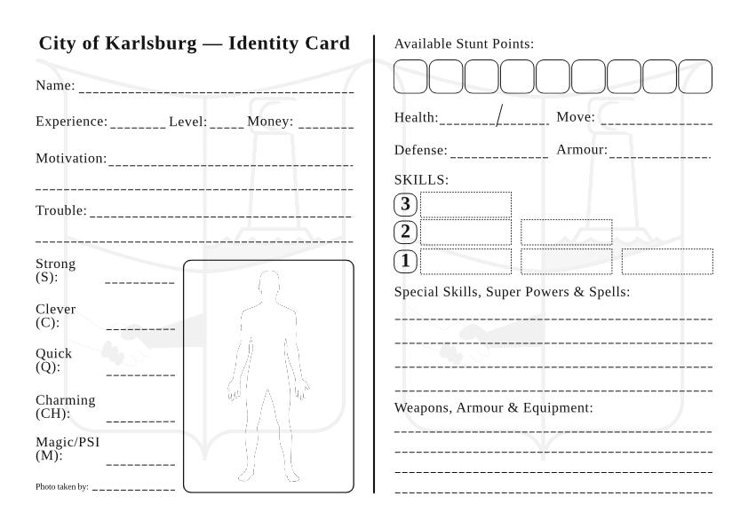

Tourist Map

Welcome to Karlsburg!

Dear Visitor,
we’d like to welcome you to our beautiful town.

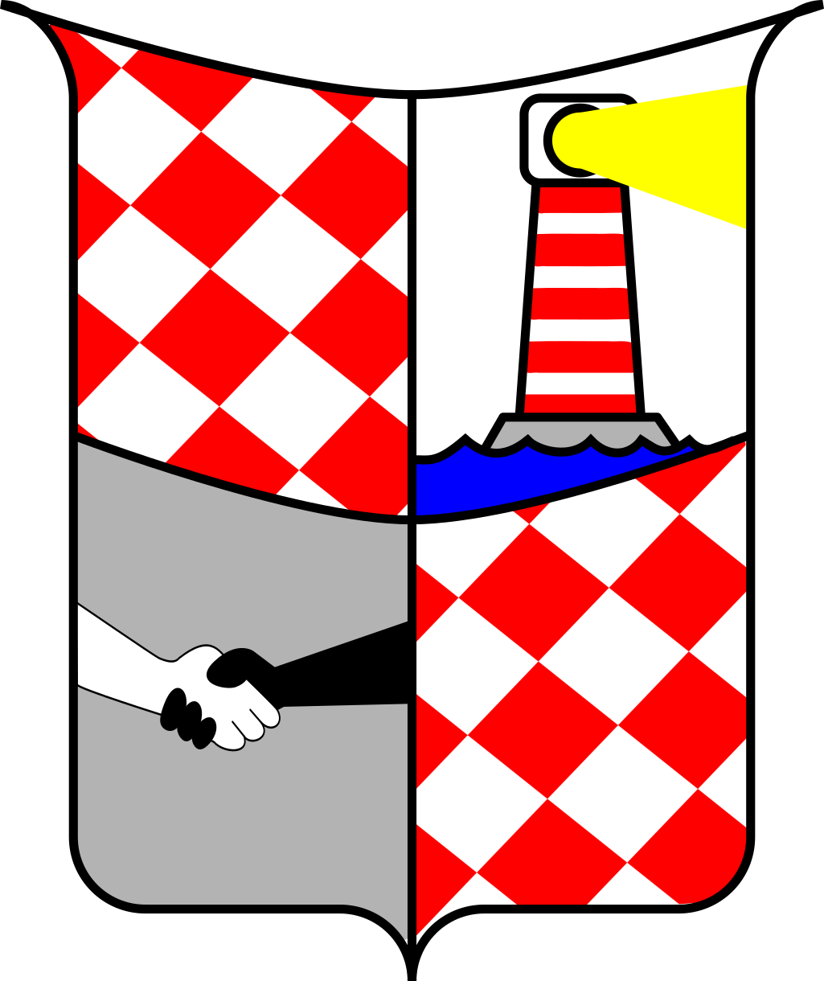
Did you know, that Karlsburg has it’s own crest? It looks like this:

The red and white checkboard was the pattern of the first settlers‘ clothes. In honour to them, this pattern has found it’s place in the crest.

The black and white hands are helping each other. It stands for the citizens and their will to help one another, not matter who he is, where he comes from, our how he was made by mother earth.

The lighthouse is a sign for the every visitor. Karlsburg tries to be light in the dark for others to find their way without harm.

You’ll find a full page map on the next side.


